PAYMENT TYPES BV SALES Donut chart

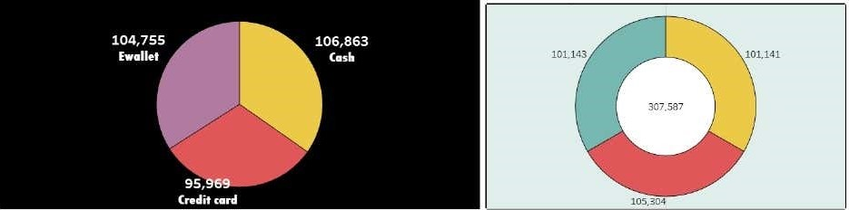

# Bubble chart WEEKDAY WISE BY SALES

|  |  |  |  |  |  |
| --- | --- | --- | --- | --- | --- |
|  | |  |  | | --- | --- | |  | 42,341 | |  | Weekday ot Date | |

sheen BarChart S%cked sheet' Bubble chart Line Chaet Donutchart Area Chart text %S51echart highI ighted chaet WoedCloud 'hart Funnel Chart 

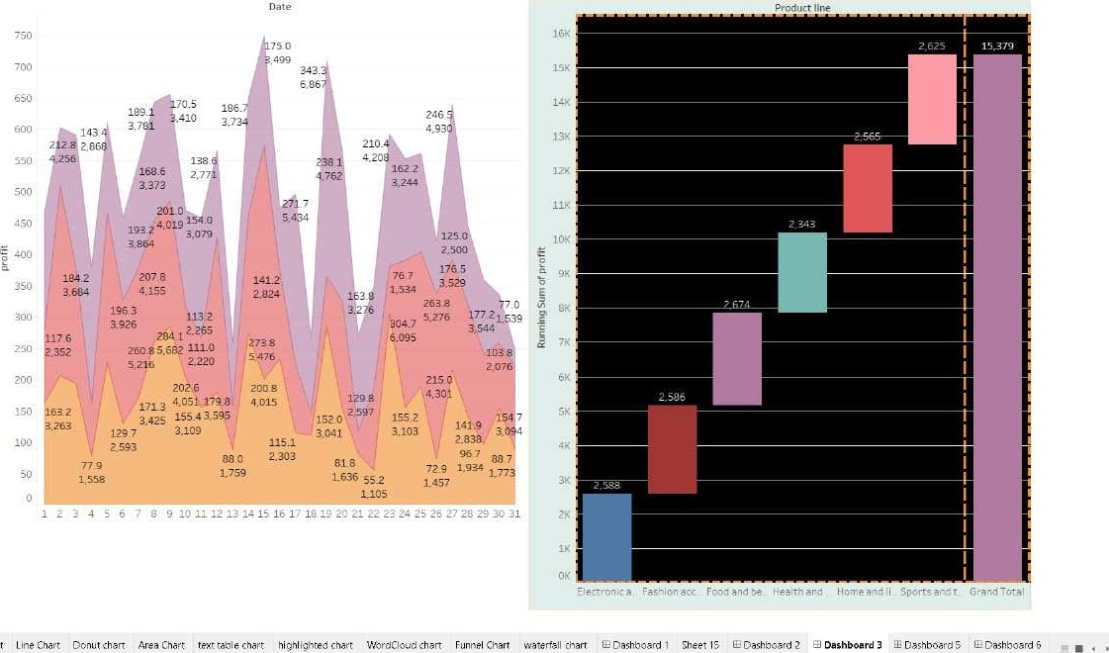

Area

Chart

waterfall

chart

sheer

WordCloud chart

Sports and travel

Fashion accessories

# Electronic accessories

## Food and beverages Health and beautyHome and lifestyle

Funnel Chart

|  |  |  |  |  |
| --- | --- | --- | --- | --- |
| |  | | --- | | Food and beverages |   Sports and travel   |  | | --- | |  | | Fashion accessories  51.720 | | Home and lifestylé | |

sheer Line Chart ArsaCharr highlighted chart INordCItJ„'d v:hart watertSI chart Dashboard 5



Product line by revenue

City

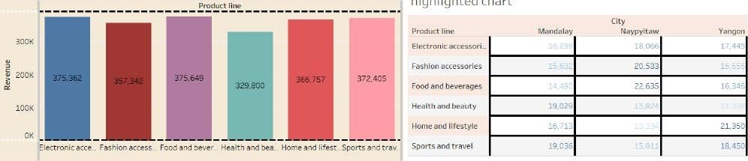

highlighted

chart

Sales

across

branch

by

product

line

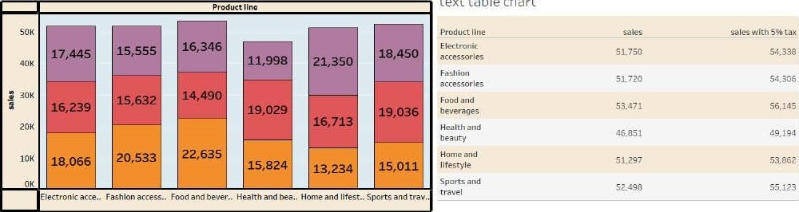

text

table

chart

sheen BarChSn  sheets Lins Don AremChattWoe d Cloud 